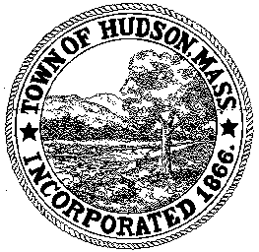

BOARD OF HEALTH
78 Main Street
Hudson, MA 01749
(978) 562-2020
Meeting Agenda
January 31, 2012
7:00 PM

- Preliminaries
1.1 Open Meeting
1.2 Roll Call

2.0 General Business
2.1 Variance Request – Sakura Restaurant

2.2 Housing Update – 130 Central Street (Robert Jordan)

2.3 Update on Community Transformation Grant

2.4 Review Septic Installer Application
Peter L. Waldron III

2.5 Minutes December 13, 2011

2.6 BOH 2011 Annual Report

2.7 Second Annual Hudson Cook-off
2/16/2012

3.0 New Business
3.1 Voucher
BOH 013112 - $1908.99
BOH 020112 - $3920.00

4.0 Old Business

5.0 Correspondence

6.0 Adjournment

Next Meeting February 14, 2012

